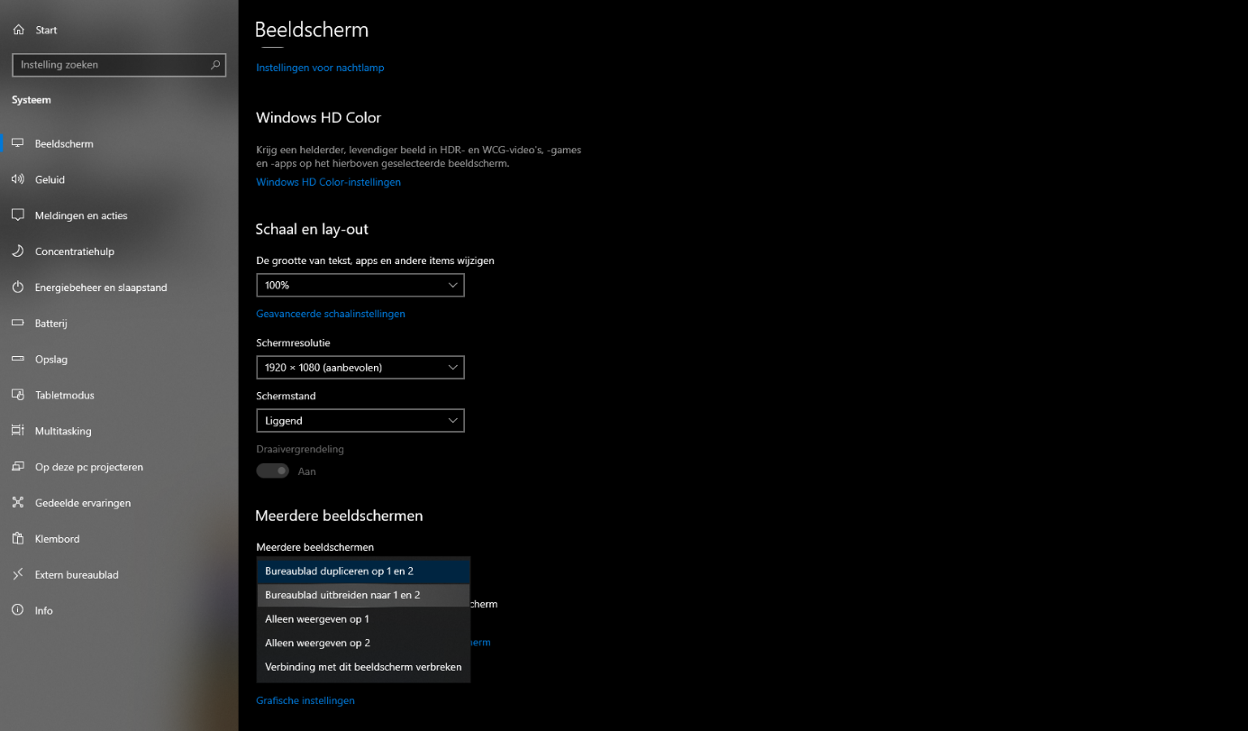

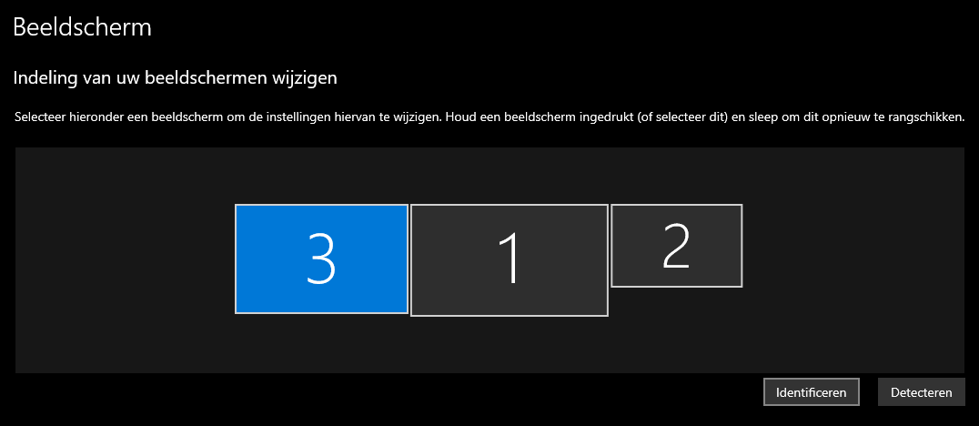

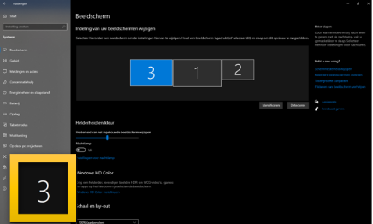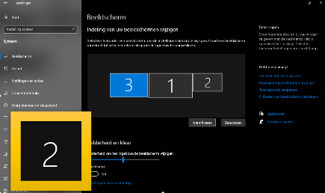

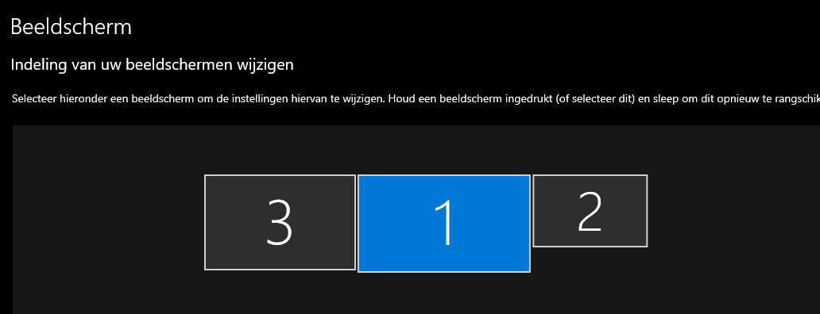

Beeldscherm

Beamer

Laptop

### 

### Win + D – Show/hide the desktop

Use the Windows logo key **(Win) + D** to minimize all your windows and go straight to your desktop. Pressing it a 2nd time restores your windows to open or full screen. If you launch apps from your desktop a lot, this provides quick access to save you time, rather than having to minimize all your open windows to get back to the desktop.

### ****Win + left arrow**** or ****Win + right arrow**** – Snap windows

Being able to snap windows and divide up your monitor space is a great Windows feature. It allows you to make the most of your monitor, viewing multiple apps at the same time. Instead of dragging windows into the side of your monitor, you can simplify the process with **Win + left arrow** or **Win + right arrow** keys, depending on which side of your monitor you want to snap to. This is especially helpful when using multiple monitors that can prevent snapping using the mouse, since in that case dragging to the side moves the window onto a different monitor.

### ****Win + I**** – Open settings

### Need to adjust your settings? ****Win + I**** takes you straight to the Settings dialogue window.

### ****Win + S****/Q– Open search

Often it is quicker to find a file or application by typing into the Windows search bar. With **Win + S,** you don’t have to take a hand off the keyboard, just use the Windows hotkey and type what you are searching for.

### ****Ctrl + A**** – Select all

Whether you want to copy or adjust formatting, **Ctrl + A** saves significant time when you want to select all the content in a given window. Instead of dragging and clicking your mouse, this selects all the text in a document or all the files in a folder.

### ****Win + L**** – Lock your computer

Locking your computer when you step away is an excellent practice to increase security. A lot of businesses make this part of company policy. It keeps your computer’s content safe from any potential bad actors. Most people who lock their computers take the scenic route, using Ctrl + Alt + Del and selecting Lock. It’s much faster with the **Win + L** shortcut.

### Win + V - Klembord

### Pressing the key combo for the first time activates the feature, and from then on you have a handy history of your copying and pasting which may save you from disaster someday.

### Win + . – emojis

Emojis

### Win + shift + S – screenshot

### Creates a platform where you can draw your screenshot in.

### 

### Function(Fn) Key Keybinds:

### F11 = Fullscreen.

### F3 = searching on google.

### F1 = hulp pagina van google chrome openen.

### F5 = de pagina opnieuw laden.

### F12 = de pagina inspecteren.

### !(Fn + esc = FnLock)!

### 

### 